Sir Sydney Dinkum
"Koala Knight"
Reader's Guide
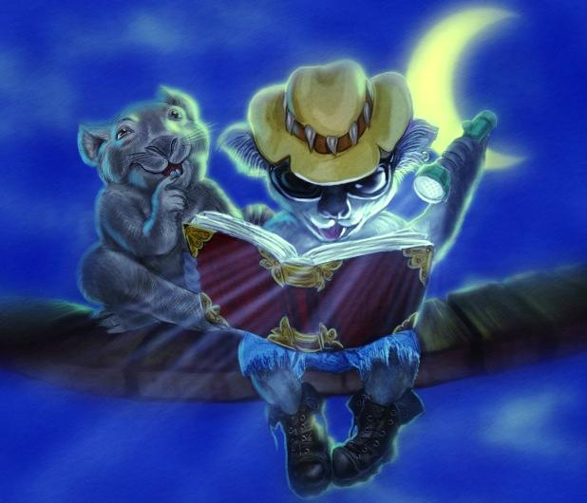

Discover the World's
Next Big Hero!
sirsydney.com

Summary:
The character of Sir Sydney Dinkum is designed to bring enjoyment, humor and adventure to young readers. More importantly, however, the books strive to enlighten and educate.
The central theme within the books explores how one should attempt to be the best they can be. What does it mean to be a good mate to others? Why is it wrong to lie? Why is it important to never break a promise?
These and other important questions are as integral to Sydney's growth and maturity as they are for young readers.
Told in a fun and easy manner, Sir Sydney's story helps developing readers find their way through the often difficult process of growing up.
Not every reader will become a knight as Sir Sydney does, but we believe by living vicariously through him, children will become better human beings and more aware of the choices we all must make.

Theme:
The Sir Sydney series demonstrates that super heroes don't need super powers. Anyone can battle the wrongs of the world, all they need is the determination to change things for the better.
Sydney's "powers" are purposefully designed to be attainable by any reader, thus making his character relatable and his achievements within reach.
His first power is the ability to stick behind his decisions. He is tenacious and dedicated to his cause, whatever it may be.
His second power is his ability to communicate. There is no need to be super human to communicate with one's fellow human beings and Sydney makes it clear that all of us need to strive towards this goal.
His final power is his ability to grow and learn. Dreams only make sense to those who seek higher ground. Through his example, young readers will come to realize we are only limited by our imaginations.

Subject Matter:
* The first book in the series takes place in Australia. The flora, animals, aboriginal culture, geography and some historical information is explored.
* Dreams are integral to the development of the plot. Their powerful effect on our daily lives is explored.
* Knighthood is a central theme. Sydney's progression from happy-go-lucky individual to determined koala knight is the main character's arc for the first book.
* Sydney's noble steed, Rosie the Camel, is deaf. Her relationship with him introduces readers to those who are disabled - how they are perceived and treated by others and how they learn to overcome their disability.
* Friendship and all that it entails is a key element of the book. Much of the conflict that arises in the book comes from Sydney's desire to "be a true mate" while at the same time attempting to follow his calling.

Conclusion:
In addition to the life lessons Sir Sydney explores, the books are also meant to expand the reader's cognitive and reading skills.
Done in a gentle fashion, new vocabulary is constantly being introduced. Sentence structure gradually advances throughout the series, and thematic content becomes more in-depth.
Young readers will fall in love with Sydney and the other characters they meet. By relating to them in their own personal way they will have great fun following the adventures while expanding their minds and horizons.
Sir Sydney can't fly or stop bullets but he's as powerful a warrior against evil as any comic book character.
Our hope is that our readers will discover their own powers and become heroes and knights for the modern age.

