Sir Sydney Dinkum
Teacher's Guide
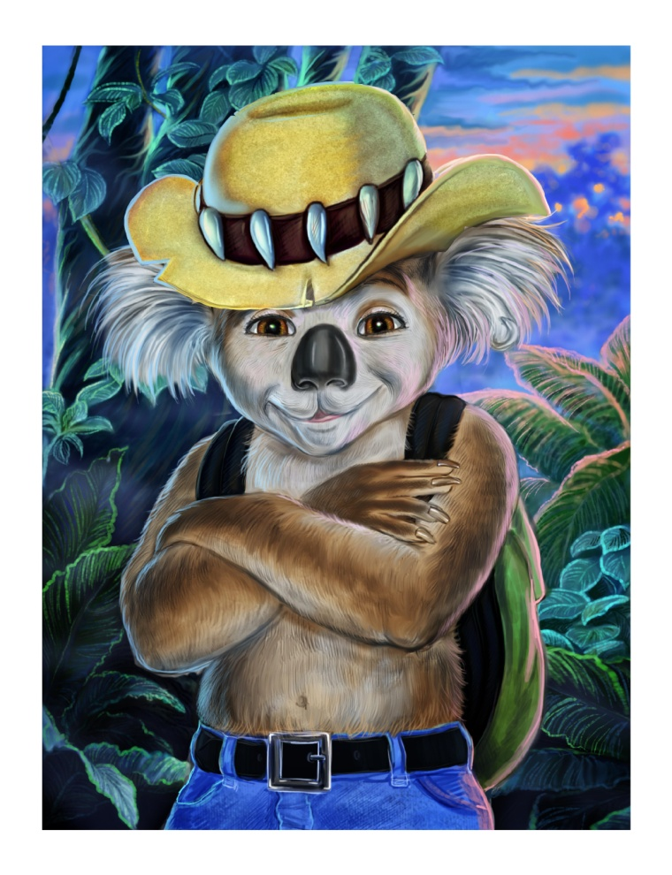
Includes
Suggested Activities & Lesson Plans
Comprehension Quiz
Vocabulary Quiz
Literacy Quiz

Sir Sydney Dinkum
Teacher's Guide
All of the material in this guide is available for free download in both PDF and Word files at www.sirsydney.com

Summary:
The character of Sir Sydney Dinkum is designed to bring enjoyment, humor and adventure to young readers. More importantly, however, the books strive to enlighten and educate.
The central theme within the books explores how one should attempt to be the best they can be. What does it mean to be a good mate to others? Why is it wrong to lie? Why is it important to never break a promise? These and other important questions are as integral to Sydney's growth and maturity as they are for young readers.
Told in a fun and easy manner, Sir Sydney's story helps developing readers find their way through the often difficult process of growing up. Not every reader will become a knight as Sir Sydney does, but we believe by living vicariously through him children will become better human beings and more aware of the choices we all must make.
In addition to the life lessons Sir Sydney explores, the books are also meant to expand the reader's cognitive and reading skills. As anyone who knows Sydney will tell you, words are everything to him. In fact, on page one of the first book of the Sir Sydney series, that's exactly what it says.
Done in a gentle fashion, new vocabulary is constantly being introduced. Sentence structure gradually advances throughout the series, and thematic content becomes more in-depth. Figures of speech such as similes, metaphors and personification are also explored in an easy and understandable fashion.
Young readers will fall in love with Sydney, Sancho, Rosie and the other characters they meet. By relating to them in their own personal way they will have great fun following the adventures while at the same time expanding their minds and horizons.
Theme:
The Sir Sydney series demonstrates that super heroes don't need super powers. Anyone can battle the wrongs of the world; all they need is the determination to change things for the better.
Sydney's "powers" are purposefully designed to be attainable by any reader, thus making his character relatable and his achievements within reach for those who choose to follow his lead.
His first power is the ability to stick behind his decisions. The ability to know right from wrong is a learnable skill however when Sydney knows the right path, nothing will stop him from reaching his destination. He is tenacious and dedicated to his cause, whatever it may be. This is a core skill or power we hope Sydney can introduce to young readers.
His second power is his ability to communicate. He is a master of languages and words are everything to him. With some effort, any human can emulate him and this message is at the heart of the books. There is no need to be super human to communicate with one's fellow human beings and all of us need to strive towards this goal.
His final power is his ability to grow and learn. Dreams only make sense to those who seek higher ground. Through his example, young readers will come to realize our aspirations are only limited by our imagination and our human potential is boundless.
Sir Sydney can't fly or stop bullets but he's as powerful a warrior against evil and wrongdoing as any comic book character. Our hope is that our readers will discover their own powers and become heroes and knights for the modern age.
Subject Matter:
* The first book in the series takes place in Australia. The flora, animals, geography and some historical information is explored.
* Dreams are integral to the development of the plot. Their powerful effect on our daily lives is explored in depth.
* Knighthood and all it entails is a central theme. Sydney's progression from happy-go-lucky individual to determined koala knight is the main character's arc for the first book.
* The Australian Aborigines are the ones who raised Sydney and his personality is deeply affected by this upbringing. Various cultural aspects of this culture are explored within the context of Sydney's maturation process.
* Sydney's noble steed, Rosie the Camel, is deaf. This was done to bring awareness to those with handicaps: how they are perceived and treated by others and how they learn to overcome their disability.
* Friendship and all that it entails is a key element of Sydney and Sancho's relationship. Much of the conflict that arises in the book comes from Sydney's desire to "be a true mate" while at the same time attempting to follow his calling.
Suggested Activities and Lesson Plans:
1. Australia:
* Many of the exotic animals of Australia are introduced in the first book. Each student can select an animal and do further study of its behavior, diet, idiosyncrasies, etc., with a short oral report in front of the class. Emphasis can be put on loss of habitat and other threats to the population.
* Sydney's travels take him to many parts of Australia. A lesson in the geography of the "Island Continent" will help students understand the enormous breadth of his journey and give a better appreciation of "Earth's largest island and smallest continent."
* Additional discussion of Australia's flora and how the animals survival depends on various plants and habitat can be very valuable to the students in helping them understand the fragile balance existing in nature.
2. Dreams:
* Sydney's adventures begin with a dream. Each student can relay a dream they have had and tell what they think it meant and how it has affected their daily lives. Allow for discussion of why some people remember their dreams and others don't and why some dreams affect us more than others.
* Begin an open discussion amongst the class about what dreams mean, if anything, and where do they come from. Do parts of our dreams come from our waking lives or not? Is there a real connection between our sleeping hours and our waking hours?
* After reading the book, discuss how Sydney's dreams affected him. Have the students say what the Australian Aborigines believe about dreams.
3. Heroes and Knights:
* Have each student tell about his favorite super-hero. They should say why this character is their favorite and what super powers they have.
* Each student can then tell about their favorite hero in their personal lives, be it their older brother, father, best friend, etc. Have them say what normal human powers their hero has and how these "powers" make them a hero.
* Have a discussion about the differences between super-heroes and real-life heroes. What defines a hero?
* Have the class list various personality traits that could be considered "super powers." Ask each student what powers they would like to have.
* Through open discussion, explore the possibility that even normal humans can be super-heroes. Have the students say what they think a real hero is and what their responsibilities are.
* Explain to the students who the knights of old were and explore the Code of Chivalry, ie., to be loyal, truthful, honorable, etc.
* Have the students find instances where Sydney displays the attributes of a knight and when he struggles to fulfill them.
* Have each student say if and why it's important for the world to have heroes and knights.
* Ask the students what they would like to change in the world if they were hero or a knight.
4. Aborigines:
* Explain to the students who the Australian Aborigines are and compare it to the meaning of indigenous people.
* Have the students tell how Sydney's upbringing with an aboriginal tribe affected him. What skills did he learn? What did he learn about the importance of dreams? What personality traits did he get from his connection with the Aborigines.
5. Deafness:
* Ask the students if they know or have ever known someone with a disability. Have them describe how they feel when they are around this person.
* Open a discussion about what it must be like having a disability. Use Rosie as an example. How did the other camels treat her? How did their treatment make her feel? How was she treated during the Miss Camel Competition? How does Sydney react to this treatment?
* Have the students elaborate on how Rosie has compensated for her deafness. Why does Rosie feel she must prove something to the world?
* Ask the students how Sancho first feels about Rosie and how does he feel later in the book. Compare this to how Sydney feels about Rosie's deafness.
* Have an open discussion about how the students would like to be treated if they were deaf or had some sort of disability.
* Undeniably, Rosie becomes a hero by the end of the book. Ask the students how this made them feel about her. Would it have been different if she had become a hero and was not deaf? If so, why?
6. Friendship:
* Have each student tell about his or her best friend. Let them explain why this person is their best friend. What qualities in a person make a good friend? If they had to create a friend from scratch, what qualities would they want in that friend.
* Have a discussion about Sydney and Sancho's friendship. At what times do both of them struggle to be good friends.
* Have each student say why they make a good friend to others. What can their friends expect from them. What do they do or not do for their friends. Ask for specific instances when they were a great friend to someone and when they failed at being a good friend. What would they like to change about themselves so that they would make a better friend to someone.
* Ask the students if there is ever a time when a person must choose to follow their own path even if their friend(s) don't want them to.
* Have a discussion about if and why it's important to have friends.

Sir Sydney Dinkum
Comprehension Quiz

1. When was the first time Sydney and Sancho did something as a team?
(A) When they took on the crocodile together.
(B) When they spoiled Happy Larry's New Year's Eve party.
(C) When they built Chok-A-Blok.
(D) When they built a model airplane from scratch.
2. Who told Sydney how to become a knight.
(A) Zach the Emu
(B) Chip Horn
(C) The crocodile
(D) The Dark Knight
3. What is Ripper?
(A) Sancho's pet fish.
(B) Sydney's nickname.
(C) The drink Sydney likes to have at Happy Larry's.
(D) Sydney's boomerang.
4. Sydney's noble steed is a what?
(A) Camel.
(B) Sports car.
(C) Kangaroo.
(D) Jet ski.
5. In Sydney's first dream, what does he do when the Dark Knight charges him?
(A) He sends up a white flag of surrender.
(B) He uses his shield to stop the lance from hitting him.
(C) He ducks.
(D) He throws a banana peel.
6. Of all the languages Sydney can speak, which does he believe is the most difficult?
(A) Chinese
(B) Wombat
(C) Crocodile
(D) Australian Slang
7. In his third dream, when he is flying, what does Sydney see in the desert?
(A) An army of angry green lizards.
(B) Two emus.
(C) A camel.
(D) The Horn family.
8. When Sydney ruins Happy Larry's New Year's Eve party, what does he say everyone in the crowd must do?
(A) Hip hop dancing.
(B) A hundred push-ups.
(C) Make funny faces.
(D) Change what they're doing.

9. When Sydney meets the two emus in the desert what does he demand they do?
(A) Rescue their friends.
(B) Take a bath.
(C) Try to fly.
(D) Find his noble steed.
10. What is Sydney's favorite food?
(A) Bamboo leaves.
(B) Matilda's Famous Breakfast Pastry
(C) Chili.
(D) Eucalyptus leaves.
11. Who tells Sydney that Rosie is the last of the Ancient Ones?
(A) Mrs. Horn.
(B) Bill.
(C) An old Aborigine.
(D) Jack and Ethan.
12. What is evil Jack's last name?
(A) Dinkum
(B) Reilly.
(C) Spratt.
(D) Hammer.

13. What is Sancho's favorite activity?
(A) Sleeping.
(B) Playing guitar.
(C) Climbing trees.
(D) Tap dancing.
14. What is the Grand Prize of the Camel Cup Competition?
(A) A remote controlled helicopter.
(B) An all-expenses paid trip anywhere on earth.
(C) A trip to outer space.
(D) A million dollars.
15. Where does the Horn family live?
(A) Sydney, Australia.
(B) Perth, Australia.
(C) Melbourne, Australia.
(D) Alice Springs, Australia.
16. In the Miss Camel Cup Competition, why does Sydney tell the Judge that he and Rosie won't be able to participate in the final competition?
(A) Rosie has to go to the bathroom.
(B) Sydney has to go to the bathroom.
(C) Rosie can't hear.
(D) The crowd is scaring Rosie.

17. Who dubs Sydney knight?
(A) Jack Hammer.
(B) Chip Horn.
(C) Sancho.
(D) Happy Larry.
18. What does Chok-A-Blok mean in Australian slang?
(A) Overflowing.
(B) Tree house.
(C) House in the sky.
(D) None of the above.
19. What does Sydney hate being called?
(A) A sissy.
(B) A marsupial.
(C) A bird brain.
(D) None of the above.
20. Sydney needs Sancho to be his what?
(A) Bodyguard.
(B) Squire.
(C) Tour Guide.
(D) Personal Driver.

Answers:
1-C, 2-B, 3-D, 4-A, 5-C, 6-D, 7-C, 8-D, 9-A, 10-D, 11-C, 12-D, 13-A, 14-B, 15-D, 16-C, 17-D, 18-A, 19-D, 20-B.

Sir Sydney Dinkum
Vocabulary Quiz
Instructions: Each sentence or paragraph has a word in bold. Select the word which most closely matches the definition of the bolded word.
1. Words were everything to Sydney, so it's no surprise that he became more than a little peeved when someone called him a bear.
(A) nervous
(B) irritated
(C) excited
(D) happy
2. Sydney didn't have time to be scared because a moment later, the head of a very irate wombat popped up. "What is it you think you're doing, mate?" asked the wombat. "I don't suppose you asked me first if I wanted a bath?"
(A) delighted
(B) sleepy
(C) angry
(D) enormous
3. "It's not as if your name has really changed. It's sort of like a code. Get it? And only you and I know it. It'll be our top secret and everyone will be envious."
(A) bored
(B) nauseous
(C) heartbroken
(D) jealous

4. The dream unnerved him more than a little.
(A) upset
(B) pleased
(C) angered
(D) tickled
5. When Sydney wanted to appear very knowledgeable, he held the glasses in one paw and pointed.
(A) forgetful
(B) stupid
(C) manly
(D) intelligent
6. Nevertheless, the croc seemed completely unwilling to follow orders. He swung his head around to face Sydney and let out a menacing growl.
(A) wimpy
(B) threatening
(C) encouraging
(D) friendly
7. There were patches of cheerful sunflowers growing around the entrance and a precariously balanced helicopter on the roof.
(A) carefully
(B) dangerously
(C) beautifully
(D) cleanly

8. On special occasions, however, Larry would make a concoction of eucalyptus leaves, sugar and soda water meant especially for Sydney.
(A) pie
(B) sundae
(C) mixture
(D) none of the above
9. "I'm currently savoring the last moments of what was a blissfully uneventful year."
(A) forgetting
(B) enjoying
(C) remembering
(D) acting out
10. It was just before midnight and Sydney's whole body was buzzing. He'd finished his fifth Mean Green and was partway through his sixth. He had never felt so fidgety and excited before.
(A) antsy
(B) gleeful
(C) dumb
(D) silly
11. When the last drop was drained, he made a momentous decision. If the world wasn't going to change on its own, then he'd have to take care of it.
(A) ridiculous
(B) dangerous
(C) split second
(D) important
12. Within moments, the rain began and turned the sleepy creek into a raging river. The Horns madly baled water while Sydney bravely maneuvered the boat down the churning waterway.
(A) pushed
(B) carried
(C) steered
(D) None of the above.
13. He was not at all sure Sancho would be happy to oblige but he decided he'd worry about that later.
(A) help
(B) tag along
(C) sing a song
(D) cook dinner
14. "Dreams are sources of power. They're eternal things that connect everything together."
(A) temporary
(B) expensive
(C) everlasting
(D) weird
15. "I hereby promise to be the best knight a koala can be. I swear to seek out adventure and I vow to take care of the little guy. I'll be loyal, trustworthy and honest."
(A) boring
(B) sneaky
(C) long-winded
(D) dependable
16. Over the next hour, several patrons tried to use the toilet and met with the same results until there was a large collection of groaning bodies strewn around the outhouse.
(A) dancing
(B) scattered
(C) piled
(D) buried
17. All those present were deeply touched at the lofty ideals Sydney had vowed to uphold.
(A) silly
(B) worthless
(C) impressive
(D) funny
18. For some time, he just meandered around the grove, looking at all his trees and staring up at the stars.
(A) strolled
(B) hopped
(C) skipped
(D) swam
19. "So answer me this!" he bellowed. "When you were having this dream, did you happen to pick up a map showing us how we're supposed to find this here camel?"
(A) squeaked
(B) intoned
(C) roared
(D) repeated

20. "G'day, mate!" said Sydney. "You're looking chipper today." Sancho only snorted.
(A) ugly
(B) sleepy
(C) bored
(D) perky
21. "Now that you mention it, can't say as I have," said Zach. "That's a very astute observation, Max."
(A) stupid
(B) insightful
(C) mundane
(D) None of the above.
22. Sydney looked out over the horizon. Only scattered bushes broke up the flat, desolate landscape.
(A) lush
(B) pretty
(C) bleak
(D) scenic
23. These majestic and special camels apparently had an understanding of all living things that no human possessed. No one knew if these fabled animals had really existed, but if they had, it was believed they had long since vanished from the earth.
(A) mythical
(B) expensive
(C) rare
(D) lonely

24. Back at the jeep, Ethan was all set to look for a different camel, one that didn't come with a feisty koala.
(A) angry
(B) courageous
(C) boring
(D) intelligent
25. The man howled like Sydney had made a big joke. Sydney didn't see the humor and really did want to know more about this amazing jumper named Sheila. He decided he'd let it go as the man was obviously daft.
(A) drunk
(B) lying
(C) asleep
(D) crazy

Answers: 1-B, 2-C, 3-D, 4-A, 5-D, 6-B, 7-B, 8-C, 9-B, 10-A, 11-D, 12-C, 13-A, 14-C,
15-D, 16-B, 17-C, 18-A, 19-C, 20-D, 21-B, 22-C, 23-A, 24-B, 25-D.

Sir Sydney Dinkum
Literacy Quiz
1. A catalyst is a thing or person(s) that causes change, much like a spark ignites fire. The catalyst that causes Sydney to rethink his life is ___?
(A) his strange dreams.
(B) meeting the Horns.
(C) meeting Sancho.
(D) drinking Mean Green.
2. An author uses foreshadowing to hint at something that will occur later in the story. When Sydney takes the Horns down the raging river and then pretends to rescue them, it is a clue that he will later ___?
(A) become the captain of a sailing ship.
(B) become a swimming instructor.
(C) become a Hollywood action star.
(D) become a Koala Knight.
NOTE FOR NEXT THREE QUESTIONS: Sometimes in a story a thing or action by a character is used to reveal something under the surface - more than its literal meaning. This is called symbolism.
3. After Sydney's second dream where he stands up to the Dark Knight he gives himself a proper cleaning and puts on cologne for the first time. This action disturbs Sancho - who likes the way things are - because he thinks it symbolizes ___?
(A) Sydney is embarrassed by his body odor.
(B) Sydney is trying to attract a girlfriend.
(C) Sydney is changing.
(D) Sydney is becoming a sissy.

4. In Sydney's third dream he is flying. In this instance, flying symbolizes ___?
(A) Sydney's newfound thirst for danger.
(B) Sydney growing out of his old ways.
(C) Sydney's need to get away from Sancho.
(D) Sydney's secret desire to be a bird - preferably a pigeon.
5. In the beginning of the story, Sydney loves to collect lots of things. His tree house, Chok-A-Blok is overflowing with stuff. After he becomes a koala knight, however, he takes only a few personal items on his journey. This symbolizes what?
(A) He's bored with the things he has and wants to find new stuff on his travels.
(B) He's too cheap to rent a moving truck.
(C) Personal possessions aren't important to him anymore.
(D) None of the above.
6. An antagonist in a story is the person or thing that causes a problem. In Sydney's case it is Jack Hammer and perhaps his dreams, but who is the antagonist for Sancho? Who most causes a problem in his comfortable life?
(A) The crocodile.
(B) Rosie.
(C) Happy Larry.
(D) Sydney.
7. Part of a Knight's Code is to never turn his or her back on a foe, or enemy. Choose the two times when Sydney did that.
(A) At Happy Larry's, when he split the dartboard in two.
(B) When he and Rosie charged Ethan and Jack in their jeep.
(C) When he told the Judge at the Miss Camel Competition that he and Rosie had to disqualify themselves.
(D) When he didn't duck in his second dream against the Dark Knight.
8. An important part of being a knight or hero is to dedicate one's life to helping others. This is referred to as being selfless or unselfish. When is the moment that Sydney realizes this.
(A) When he dries Mr. Horn off after he drenched him with his shower water.
(B) When he tells the Horns he won't charge them for the tour he gave.
(C) When he realizes that winning the Camel Cup Competition is not about him but about Rosie proving herself to the world.
(D) When he tells Sancho he can join him and Rosie on their Grand Prize trip.
9. It's not always easy being a good friend and this is true for Sancho. What instance do you think is the hardest for Sancho to be a true mate?
(A) When he agrees to be Sydney's squire.
(B) When he agrees to go to the desert in search of Sydney's noble steed
(C). When he goes to the New Year's Eve party even though he doesn't want to.
(D) When he helps to build Chok-A-Blok even though he's afraid of heights.
10. Many times Sydney is forced to trust Rosie. Which time do you think is the most important to the story?
(A) When they are lost in the desert and he decides to let her find the way out.
(B) When they are in the mountains at night and he must trust her to follow the dangerous path without falling.
(C) When Ethan and Jack are charging them in their jeep and Sydney trusts Rosie to charge back.
(D) At the Miss Camel Cup Competition when he trusts her to read his mind and know when he is calling her to come to him.

11. At one point in the story, Sydney's dream about facing the Dark Knight is recreated in real life. Pick the moment this occurs.
(A) When he faces down the crocodile.
(B) At Happy Larry's,when he clobbers the guy who wants to use the toilet.
(C) When he and Rosie charge Ethan and Jack's jeep.
(D) When he and Rosie win the Camel Cup race.
12. When Sydney and Sancho meet the two emus in the desert, Sydney shows a particular trait that all knights have. Sancho wants to ask the emus for a ride, but Sydney tells them they must go and rescue their friends. What trait is this?
(A) Selflessness
(B) Silliness
(C) Bravery
(D) Loyalty
13. Even though Sydney and Sancho are both marsupials, they have very different personalities. What do you think is the biggest difference between the two?
(A) Sydney likes heights and Sancho doesn't.
(B) Sydney can speak many languages and Sancho can't.
(C) Sancho hates when things change and Sydney tries to make change happen.
(D) Sydney has weird dreams and Sancho doesn't.
14. Usually new characters are brought into a story so that they can somehow affect the main character. What do you think is the most important reason the Horn family is introduced when they are?
(A) Sydney is broke and needs a tour to make some money.
(B) Sydney needs the Horns to help him understand what his dreams mean.
(C) So Sydney can rescue them from the crocodile and feel like a knight.
(D) Sydney is bored with Sancho and needs some new friends.
Answers: 1-A, 2-D, 3-C, 4-B, 5-C, 6-D, 7-B&D, 8-C, 9-B, 10-D, 11-C, 12-A, 13-C, 14-B

